East Grinstead & District Lions Club CIO
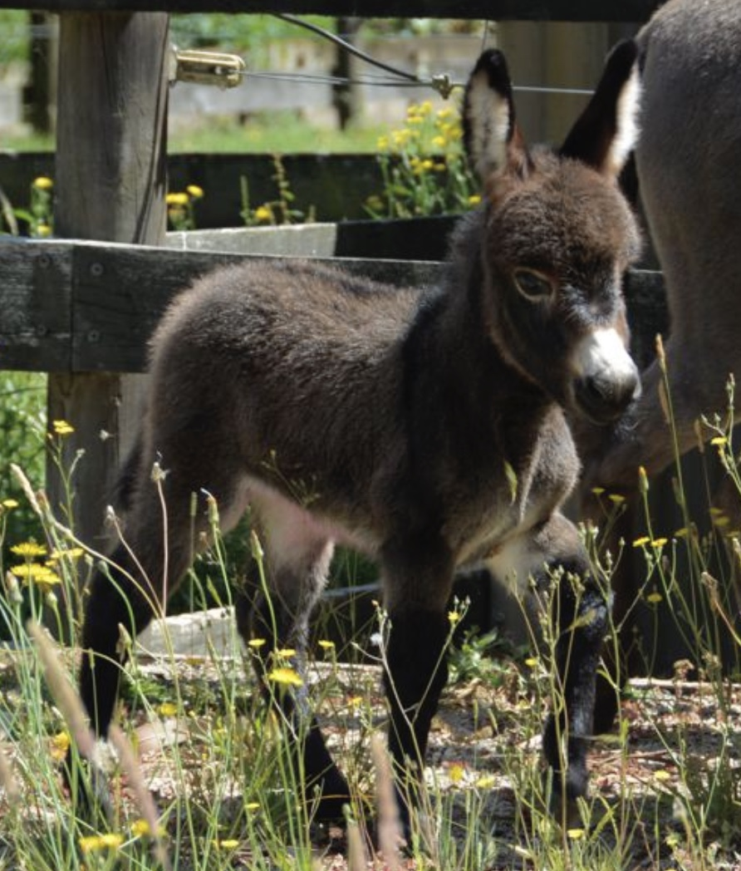
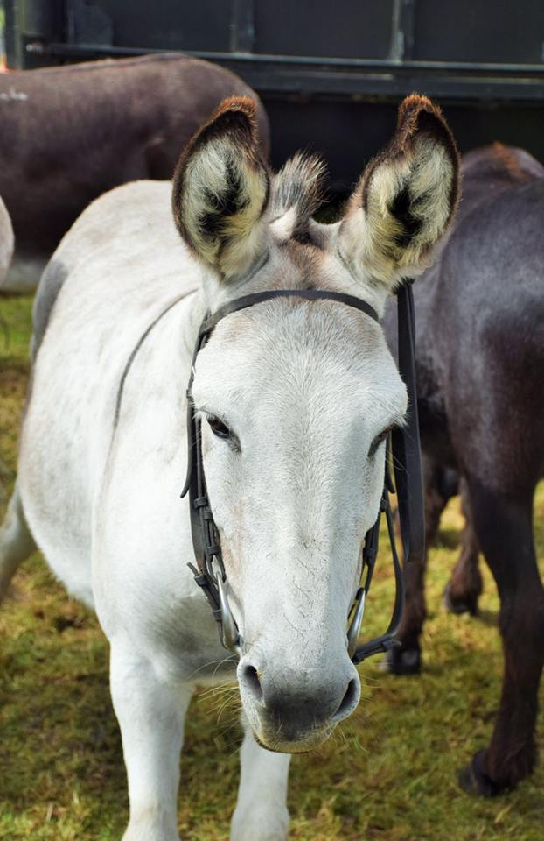
Registered Charity 1179721
Donkey Derby
25th July 2021
King Georges Field
Moat Road, East Grinstead

Race Sponsorship £150
Company/Business/Personal………………………………………………………………………………………
Address…………………………………………………………………………………………………………………………
Telephone no/website/FB…………………………………………………………………………………………
(For businesses - all of the above to be included in race card. Personal sponsors choose text to be included)

And/Or

Donkey Name £25
Personal example: Name: Dad's DIY Disaster
Breeding: By Dodgy fixing out of Try Again
Sponsor: The Smith Family
Business example: Name: Tanned Beauty
Breeding: By Golden Glow out of Sprayed On
Business: The Tanning Bureau

Name:…………………………………………………………………………………………………………Max 20 chrs
Breeding:.By…………………………… out of ……………………………Max 40 chrs incl spaces
Business/Personal: ………………………………………………………………………………………name only
(above to be included in race card)
Contact address:…………………………………………………………………………………………………………….
Contact Tel no…………………………………………………………………………………………………………………

If sponsoring more than 1 race or donkey please complete on a separate copy.

Please complete and return with payment (cheque payable to East Grinstead & District Lions Club CIO) or BACS payment to Barclays Bank, Sort code 20-88-13 Activities a/c 93130835 (Please include DD (short for donkey derby) & a reference our treasurer can tie up with your form) Alternatively, after paying by BACS, email your form to eganddlions@gmail.com.

Brian Richens
EG Lions
For queries please ring/message 07743 742801
38 Campbell Crescent
East Grinstead
RH19 1JR

